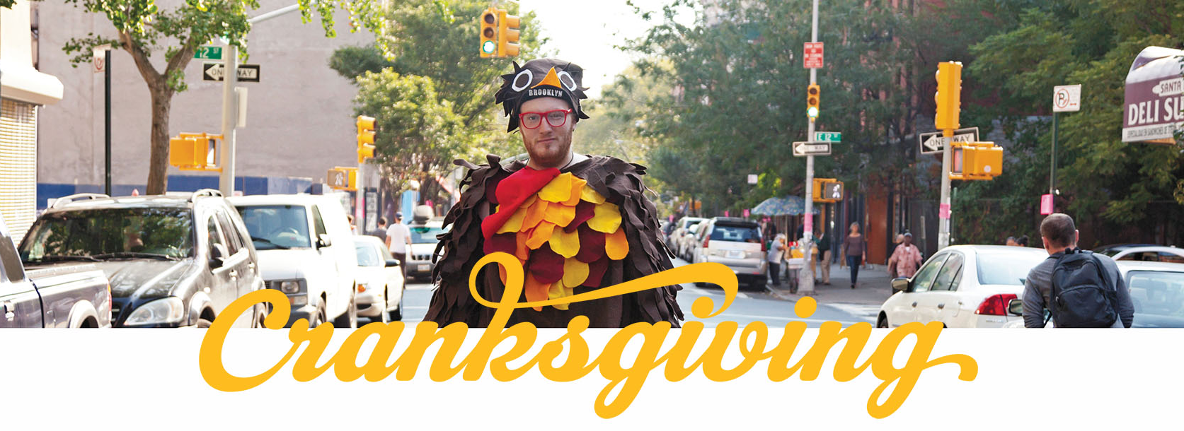
For Immediate Release
Contact(s):
Your Name Here
Your Phone Here
email@emailaddress.com
Cranksgiving: Pedaling to End Hunger
The world's largest food drive on two wheels puts food on tables for the holidays
(your city, state – today's date) The idea is simple: collect food and do it on a bicycle. The rules are minimal: be safe and have fun. The cause is an excellent one, and on [day – date] cyclists of all ages and abilities will gather to collect food for [Insert Charity name here].
Cranksgiving started as friendly competition between bike messengers in New York City in 1999, and has since grown into a movement that has swept cycling communities around the world. Nationally, Cranksgiving events generate more than a million meals for families in need each year.
[OPTIONAL EVENT DETAILS — include this if your event follows the classic alleycat format, otherwise write your own here]
Participants pedal throughout the city to visit area grocery stores and collect holiday food items from a secret scavenger hunt list, or "Manifest." Based on messengers' alleycat race format, cyclists can choose their own route (using streets, bike paths, and little-known shortcuts) to get to their destinations. The Manifest is a collaboration between event organizers and a local charity who determine the sought after non-perishable food items and other high-demand items, such as toiletries or diapers.
Cyclists complete their ride by returning to the starting point within the time allotment. Bonuses may be given out for completing challenges, solving puzzles and collecting specific food items. There is no experience necessary — all ages and abilities on a bike are welcome.
[END OPTIONAL SECTION]
Event organizer [your name] notes, "Every year around the holidays food supplies are stretched to their limits providing for families in need. This event harnesses the boundless enthusiasm of the local bicycle community to do a little bit of good for the holidays. We all have a blast and [charity] benefits!"
Participants should arrive to register no later than [start time]. All that is needed are a bike, a bag or backpack, a bike lock and $20-$25 to buy food. There is no entry fee. Bike helmets are also mandatory. This year's event starts and finishes at [location name]. To learn more, or to RSVP visit: [website url or Facebook page]
Can't make it to the event? Bring a food or monetary donation to [Charity name].
About Cranksgiving
Cranksgiving started in New York City in 1999 and has since grown into a nationwide movement, with rides in major cities like New York, Los Angeles, and Chicago, as well as smaller communities such as Moscow, ID and Sequim, WA. These rides have even caught the attention of national media like NBC's Today Show. To learn more or to find the Cranksgiving happening in other cities, visit Cranksgiving.org.
LOCAL EVENT DETAILS
Event Name: Cranksgiving (your town)
When: date | time
Where: location
URL: www….

Online Donation Link: if applicable
Social Link(s): add your socials here
Hashtags: #cranksgiving2026, #cranksgiving, add your own!
Partners: @handles for participating bike shops, food banks, sponsors

